## Proximity Sensor on Mobile Phones

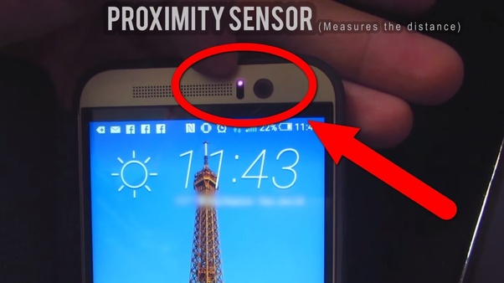

Proximity is a type of an electronic sensor, which can detect presence of any nearby objects without any actual physical contact. They are used in vehicles for detecting the proximity of other vehicles relative to one's own car and also for parking functions. They can also be used in mobile phones like to turn off the 33screen during phone call or while in the pocket to save battery and for false touch. The sensors are on when it senses nearby objects like ear or wall of pocket.

**What it has?**

* It consists of IR transmitter and receiver pair.

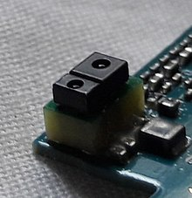

Proximity Sensor used in Mobile Phone.

**Transmitter**

* It is an LED and emits a beam of electromagnetic radiation in the form of infrared light.
* If placed an object close to the transmitter, the light will bounce back.
* And this light is picked up by the receiver.

Submitted by:

Tej Singh Chaudhary